**COLLEGE MANAGEMENT STAR SCHEMA**

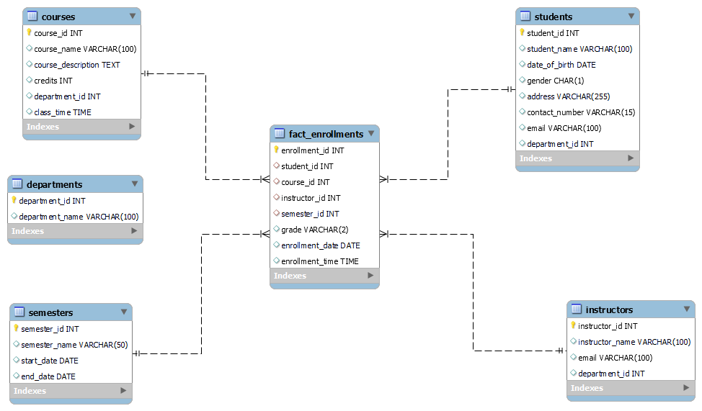

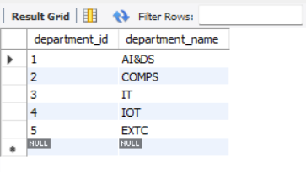

CREATE TABLE departments (

department_id INT PRIMARY KEY,

department_name VARCHAR(100) NOT NULL

);

INSERT INTO departments (department_id, department_name) VALUES

(1, 'AI&DS'), (2, 'COMPS'), (3, 'IT'),(4, 'IOT'), (5, 'EXTC');

SELECT * FROM departments;

CREATE TABLE students ( student_id INT PRIMARY KEY, student_name VARCHAR(100) NOT NULL,

date_of_birth DATE NOT NULL, gender CHAR(1) NOT NULL, address VARCHAR(255) NOT NULL,

contact_number VARCHAR(15) NOT NULL, email VARCHAR(100) NOT NULL UNIQUE,

department_id INT NOT NULL, FOREIGN KEY (department_id) REFERENCES departments(department_id) );

INSERT INTO students (student_id, student_name, date_of_birth, gender, address, contact_number, email, department_id) VALUES

(1, 'Alice Johnson', '2000-01-15', 'F', '123 Main St, Cityville', '123-456-7890', 'alice.johnson@acpce.ac.in', 1),

(2, 'Bob Smith', '1999-06-23', 'M', '456 Elm St, Townsville', '987-654-3210', 'bob.smith@acpce.ac.in', 2),

(3, 'Charlie Brown', '2001-08-30', 'M', '789 Oak St, Villagetown', '555-123-4567', 'charlie.brown@acpce.ac.in', 3);

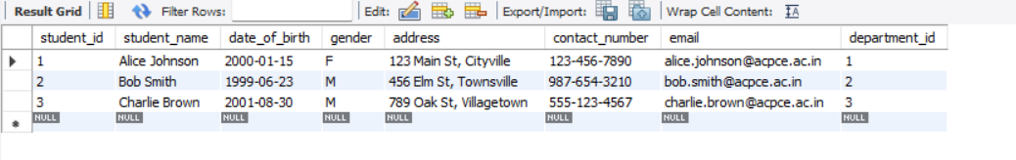SELECT * FROM students;

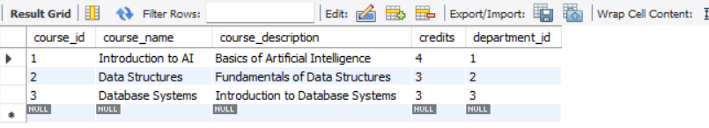CREATE TABLE courses (

course_id INT PRIMARY KEY,

course_name VARCHAR(100) NOT NULL,

course_description TEXT NOT NULL,

credits INT NOT NULL,

department_id INT NOT NULL,

FOREIGN KEY (department_id) REFERENCES departments(department_id) );

INSERT INTO courses (course_id, course_name, course_description, credits, department_id) VALUES

(1, 'Introduction to AI', 'Basics of Artificial Intelligence', 4, 1),

(2, 'Data Structures', 'Fundamentals of Data Structures', 3, 2),

(3, 'Database Systems', 'Introduction to Database Systems', 3, 3);

SELECT * FROM courses;

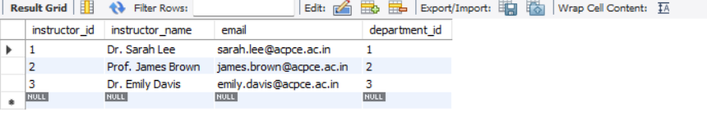CREATE TABLE instructors (

instructor_id INT PRIMARY KEY,

instructor_name VARCHAR(100) NOT NULL,

email VARCHAR(100) NOT NULL UNIQUE,

department_id INT NOT NULL,

FOREIGN KEY (department_id) REFERENCES departments(department_id) );

INSERT INTO instructors (instructor_id, instructor_name, email, department_id) VALUES

(1, 'Dr. Sarah Lee', 'sarah.lee@acpce.ac.in', 1),

(2, 'Prof. James Brown', 'james.brown@acpce.ac.in', 2),

(3, 'Dr. Emily Davis', 'emily.davis@acpce.ac.in', 3);

SELECT * FROM instructors;

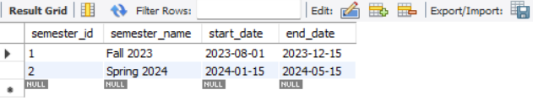CREATE TABLE semesters (

semester_id INT PRIMARY KEY,

semester_name VARCHAR(50) NOT NULL,

start_date DATE NOT NULL,

end_date DATE NOT NULL );

INSERT INTO semesters (semester_id, semester_name, start_date, end_date) VALUES

(1, 'Fall 2023', '2023-08-01', '2023-12-15'),

(2, 'Spring 2024', '2024-01-15', '2024-05-15');

SELECT * FROM semesters;

CREATE TABLE fact_enrollments (

enrollment_id INT PRIMARY KEY,

student_id INT NOT NULL,

course_id INT NOT NULL,

instructor_id INT NOT NULL,

semester_id INT NOT NULL,

grade VARCHAR(2) NOT NULL,

enrollment_date DATE NOT NULL,

enrollment_time TIME NOT NULL,

FOREIGN KEY (student_id) REFERENCES students(student_id),

FOREIGN KEY (course_id) REFERENCES courses(course_id),

FOREIGN KEY (instructor_id) REFERENCES instructors(instructor_id),

FOREIGN KEY (semester_id) REFERENCES semesters(semester_id)

);

INSERT INTO fact_enrollments (enrollment_id, student_id, course_id, instructor_id, semester_id, grade, enrollment_date, enrollment_time) VALUES

(1, 1, 1, 1, 1, 'A', '2023-08-05', '10:00:00'),

(2, 2, 2, 2, 1, 'B+', '2023-08-10', '11:00:00'),

(3, 3, 3, 3, 2, 'A-', '2024-01-20', '09:00:00');

SELECT * FROM fact_enrollments;

